Nang Thiri Wutyi

20113

9/30/2024

**Verilog Lab HW 2**

1. **ReductionOperators**

module ReductionOperators();

initial begin

// Bit Wise AND reduction

$display (" & 4'b1001 = %b", (&4'b1001));

$display (" & 4'bx111 = %b", (&4'bx111));

$display (" & 4'bz111 = %b", (&4'bz111));

// Bit Wise NAND reduction

$display (" ~& 4'b1001 = %b", (~&4'b1001));

$display (" ~& 4'bx001 = %b", (~&4'bx001));

$display (" ~& 4'bz001 = %b", (~&4'bz001));

// Bit Wise OR reduction

$display (" | 4'b1001 = %b", (|4'b1001));

$display (" | 4'bx000 = %b", (|4'bx000));

$display (" | 4'bz000 = %b", (|4'bz000));

#10 $finish;

end

endmodule

**Results**

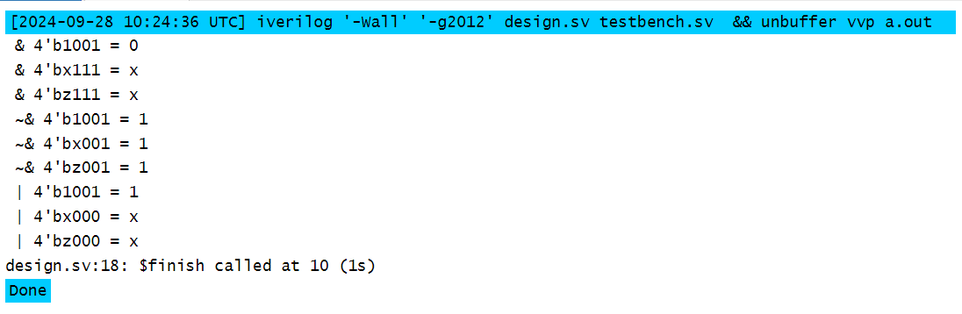

**ShiftOperators**

module ShiftOperators();

initial begin

// Left Shift

$display (" 4'b1001 << 1 = %b", (4'b1001 << 1));

$display (" 4'b10x1 << 1 = %b", (4'b10x1 << 1));

$display (" 4'b10z1 << 1 = %b", (4'b10z1 << 1));

// Right Shift

$display (" 4'b1001 >> 1 = %b", (4'b1001 >> 1));

$display (" 4'b10x1 >> 1 = %b", (4'b10x1 >> 1));

$display (" 4'b10z1 >> 1 = %b", (4'b10z1 >> 1));

#10 $finish;

end

endmodule

**Results**

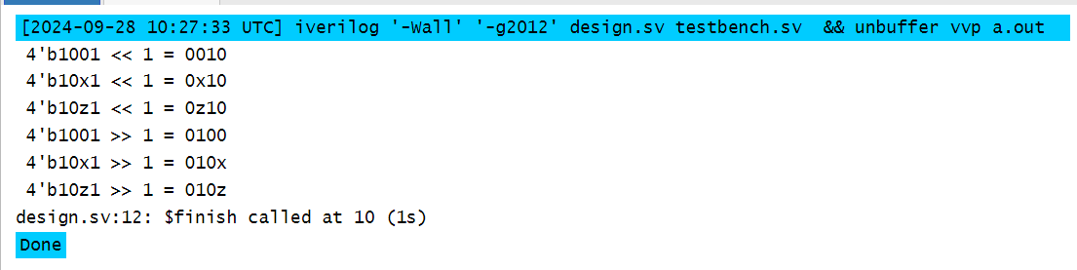

**ConcatenationOperator**

module ConcatenationOperator();

initial begin

// Concatenation

$display ("{4'b1001,4'b10x1} = %b", {4'b1001, 4'b10x1});

#10 $finish;

end

endmodule

**Results**

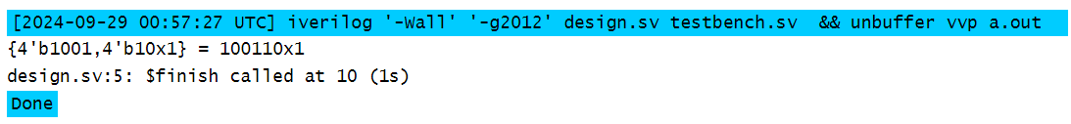

**ReplicationOperator**

module ReplicationOperator();

initial begin

// replication

$display ("{4{4'b1001}} = %b", {4{4'b1001}});

// replication and concatenation

$display ("{4{4'b1001,1'bz}} = %b", {4{4'b1001,1'bz}});

#10 $finish;

end

endmodule

Results

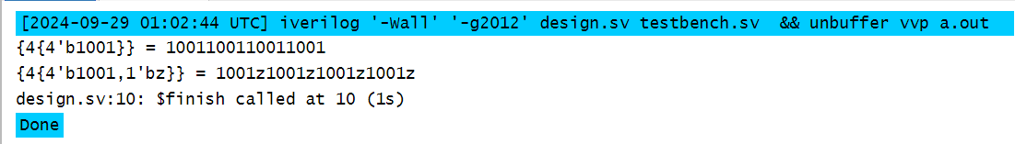

1. **Addbit module**

// Addbit Module

module addbit (

input a, // First bit

input b, // Second bit

input cin, // Carry in

output sum, // Sum output

output cout // Carry out

);

// Full adder logic

assign sum = a ^ b ^ cin; // Sum is the XOR of the inputs and carry in

assign cout = (a & b) | (cin & (a ^ b)); // Carry out is generated based on inputs and carry in

endmodule

**Adder Hier Module**

// Adder Hier Module

module adder_hier (

output [3:0] result_o, // 4-bit sum output

output carry_o, // Carry out of the final addition

input [3:0] r1_i, // First 4-bit input

input [3:0] r2_i, // Second 4-bit input

input ci_i // Carry in input

);

// Internal wires for carry between stages

wire c1_w, c2_w, c3_w;

// Instantiate addbit modules for each bit

addbit u0 (

.a(r1_i[0]), .b(r2_i[0]), .cin(ci_i),

.sum(result_o[0]), .cout(c1_w)

);

addbit u1 (

.a(r1_i[1]), .b(r2_i[1]), .cin(c1_w),

.sum(result_o[1]), .cout(c2_w)

);

addbit u2 (

.a(r1_i[2]), .b(r2_i[2]), .cin(c2_w),

.sum(result_o[2]), .cout(c3_w)

);

addbit u3 (

.a(r1_i[3]), .b(r2_i[3]), .cin(c3_w),

.sum(result_o[3]), .cout(carry_o)

);

endmodule

**Testbench Module**

// Testbench Module

module tb_adder_hier();

// Declare registers for inputs and wires for outputs

reg [3:0] r1_r, r2_r;

reg ci_r;

wire [3:0] result_w;

wire carry_w;

// Instantiate the adder_hier module

adder_hier UUT (

.result_o(result_w),

.carry_o(carry_w),

.r1_i(r1_r),

.r2_i(r2_r),

.ci_i(ci_r)

);

// Drive the inputs

initial begin

// Test case 1: Add 0 + 0 + 0

r1_r = 4'b0000;

r2_r = 4'b0000;

ci_r = 1'b0;

#10; // Wait for 10 time units

// Test case 2: Add 10 (0b1010) + 0 + 0

r1_r = 4'b1010;

r2_r = 4'b0000;

ci_r = 1'b0;

#10;

// Test case 3: Add 10 (0b1010) + 2 (0b0010) + 0

r1_r = 4'b1010;

r2_r = 4'b0010;

ci_r = 1'b0;

#10;

// Test case 4: Add 10 (0b1010) + 2 (0b0010) + 1 (carry-in)

r1_r = 4'b1010;

r2_r = 4'b0010;

ci_r = 1'b1;

#10;

$finish; // End simulation

end

// Monitor the inputs and outputs

initial begin

$display("+-----------------------------------------------+");

$display("| r1 | r2 | ci | result | carry |");

$display("+-----------------------------------------------+");

$monitor("| %b | %b | %b | %b | %b |", r1_r, r2_r, ci_r, result_w, carry_w);

$display("+-----------------------------------------------+");

end

endmodule

**Results**

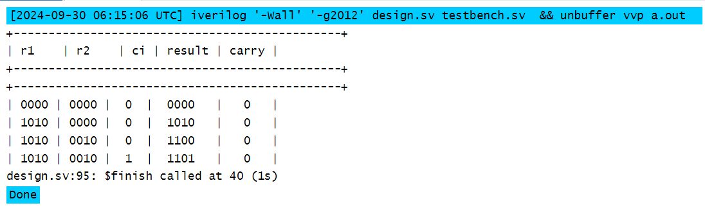

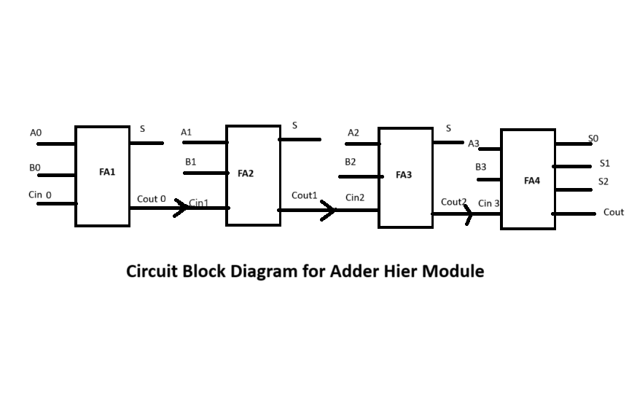

**Synchronous DFF**

// D Flip-Flop Module

`timescale 1ns / 1ps // Set the time unit to 1ns and precision to 1ps

module DFFSynch(

input d_i, // Data input

input rst_i, // Reset input

input clk_i, // Clock input

output reg q_o // Output

);

always @(posedge clk_i) begin

if (rst_i)

q_o <= 0; // Reset output to 0

else

q_o <= d_i; // Update output with data input on clock edge

end

endmodule

**Testbench**

// Testbench for D Flip-Flop

`timescale 1ns / 1ps // Set the time unit and precision

module tb_DFFSynch;

// Declare registers for inputs and wire for output

reg d_i; // Input data

reg rst_i; // Reset input

reg clk_i; // Clock input

wire q_o; // Output

// Instantiate the DFF module

DFFSynch dut (

.d_i(d_i),

.rst_i(rst_i),

.clk_i(clk_i),

.q_o(q_o)

);

// Clock generation

initial begin

clk_i = 0; // Initialize clock

forever #5 clk_i = ~clk_i; // Toggle clock every 5 time units

end

// Test sequence

initial begin

// Set up the VCD file for waveform viewing

$dumpfile("dump.vcd"); // Specify the name of the VCD file

$dumpvars(0, tb_DFFSynch); // Dump all variables in the testbench

// Monitor the output

$monitor("Time: %0dns | d_i: %b | rst_i: %b | clk_i: %b | q_o: %b", $time, d_i, rst_i, clk_i, q_o);

// Test case 1: Reset the DFF

rst_i = 1; d_i = 0; #10; // Apply reset

rst_i = 0; #10; // Release reset

// Test case 2: Set d_i to 1

d_i = 1; #10; // Set d_i to 1, should update q_o on next clock

// Test case 3: Set d_i to 0

d_i = 0; #10; // Set d_i to 0, should update q_o on next clock

// Test case 4: Check reset again

rst_i = 1; #10; // Apply reset again

rst_i = 0; #10; // Release reset

// Test case 5: Set d_i to 1 again

d_i = 1; #10; // Set d_i to 1, should update q_o on next clock

// Finish the simulation

$finish;

end

endmodule

**Results**

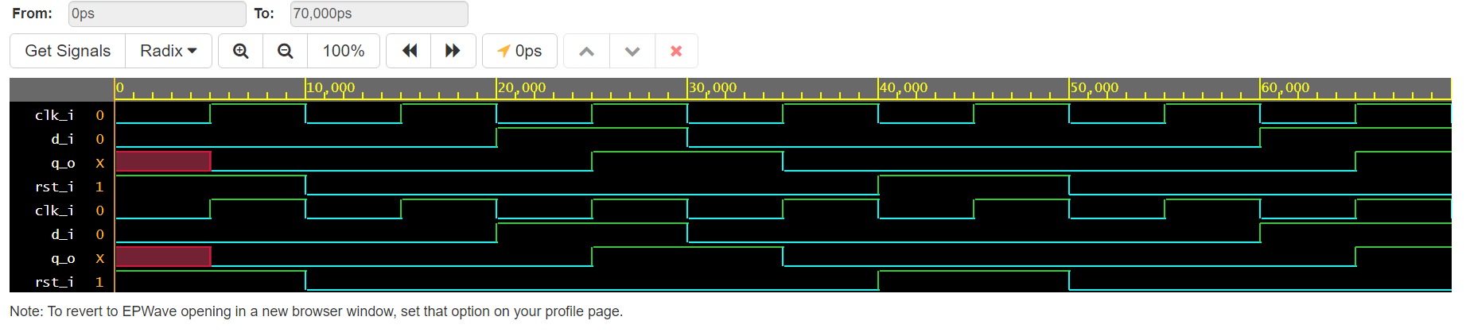

**Asynchronous DFF**

// Asynchronous D Flip-Flop Module

`timescale 1ns / 1ps // Set the time unit and precision

module DFFAsynch(

input d_i, // Data input

input rst_i, // Reset input

input clk_i, // Clock input

output reg q_o // Output

);

always @(posedge clk_i or posedge rst_i) begin

if (rst_i)

q_o <= 0; // Reset output to 0

else

q_o <= d_i; // Update output with data input on clock edge

end

endmodule

**Testbench**

// Testbench for DFFAsynch

`timescale 1ns / 1ps // Set the time unit and precision

module tb_DFFAsynch;

// Declare registers for inputs and wire for output

reg d_i; // Input data

reg rst_i; // Reset input

reg clk_i; // Clock input

wire q_o; // Output

// Instantiate the DFFAsynch module

DFFAsynch dut (

.d_i(d_i),

.rst_i(rst_i),

.clk_i(clk_i),

.q_o(q_o)

);

// Clock generation

initial begin

clk_i = 0; // Initialize clock

forever #5 clk_i = ~clk_i; // Toggle clock every 5 time units

end

// Test sequence

initial begin

// Set up the VCD file for waveform viewing

$dumpfile("dump.vcd"); // Specify the name of the VCD file

$dumpvars(0, tb_DFFAsynch); // Dump all variables in the testbench

// Monitor the output

$monitor("Time: %0dns | d_i: %b | rst_i: %b | clk_i: %b | q_o: %b", $time, d_i, rst_i, clk_i, q_o);

// Test case 1: Reset the DFF

rst_i = 1; d_i = 0; #10; // Apply reset

rst_i = 0; #10; // Release reset

// Test case 2: Set d_i to 1

d_i = 1; #10; // Set d_i to 1, should update q_o on next clock

// Test case 3: Set d_i to 0

d_i = 0; #10; // Set d_i to 0, should update q_o on next clock

// Test case 4: Check reset functionality

rst_i = 1; #10; // Apply reset again

rst_i = 0; #10; // Release reset

// Test case 5: Set d_i to 1 again

d_i = 1; #10; // Set d_i to 1, should update q_o on next clock

// Finish the simulation

$finish;

end

endmodule

**Results**

